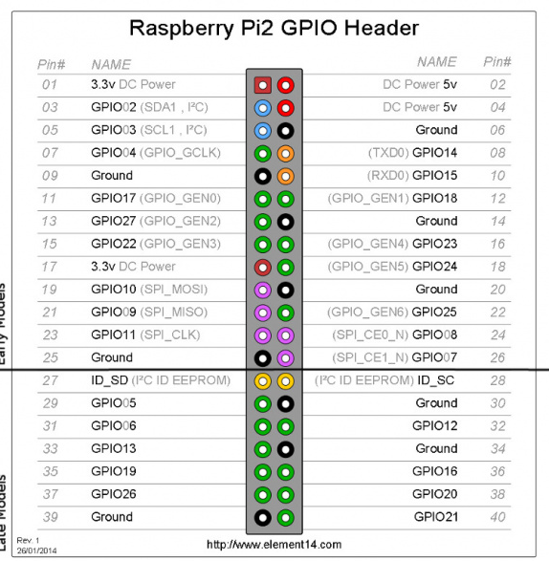Experiment# PIR Motion Sensor with Raspberrypi

Hardware Connection =Vcc=2,GND=6, Board PIN=11

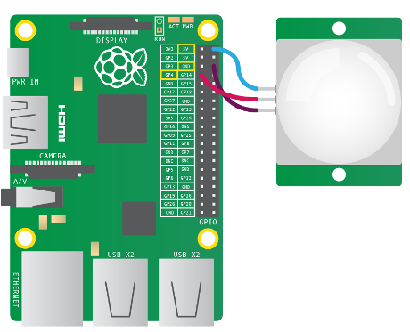

Code:

import RPi.GPIO as GPIO

import time

import subprocess

GPIO.setwarnings(False)

GPIO.setmode(GPIO.BOARD)

GPIO.setup(11, GPIO.IN) # board pin 11

while True:

i=GPIO.input(11)

if i==0:

print("Not Sensing Motion",i)

time.sleep(5)

elif i==1:

print("Motion Detected",i)

time.sleep(5)